

Option A — Scratch Implementation Guide
PART 3: Building the Prototype | Fully supported route
Purpose of this guide
This guide supports teachers and students in turning the approved Part 2 blueprint into a functioning Scratch prototype. It includes workspace orientation, the exact block categories, a screenshot-based build sequence, beginner access, saving, technical smoke checking and troubleshooting. Proper testing belongs to Part 4.

How to use this guide
• Teachers read Sections 1–3 before the lesson and open the included Part3_Chatbot_Starter.sb3.
• Beginners use Section 3 or the separate two-page Scratch Quick Start guide.
• Students build with Sections 4–8 and the short Scratch Build Card.
• Groups complete technical verification in the common Part 3 Prototype Build Record.
• Do not use the smoke check to judge quality or make improvements.
Core build rule
Keep the Part 2 worksheet open. Replace placeholders with the approved purpose, category names and responses. Do not create new content while coding.

1. What counts as a successful Scratch prototype?
A successful Part 3 Scratch prototype does not need advanced programming, animation or artificial intelligence. It needs visible, repeatable rule-based behaviour that another group can operate:
• one named chatbot sprite;
• one welcome message and purpose statement;
• one visible instruction with choices 1, 2 and 3, a 0 limits route, and a fallback for anything else;
• one ask and wait block;
• three conditional content branches;
• one separate 0 limitation/safety route;
• one final fallback for any other input;
• one visible feature linked to the Part 1 principle;
• one anonymous save/access method; and
• one completed technical build verification.
Why use 0?
The three content categories remain 1, 2 and 3. Choice 0 is not a fourth content category. It gives beginner prototypes a clear, separate way to display the chatbot’s limits, while any other unsupported input reaches fallback.

2. Before students open Scratch
Teacher readiness check | Ready when...
Part 2 blueprint | Every group has pages 1–4 and is Ready to build or has one named repair.
Scratch access | Scratch opens; students can open/remix a project or work from a local file.
Core blocks | Teacher has located green flag, say, ask and wait, answer, if/else and =.
Starter/reference | The included Part3_Chatbot_Starter.sb3 is preloaded and already contains the 1–2–3–0–other structure shown in this guide.
Saving | Teacher has tested remix/save or File → Save to your computer.
Contingency | A paper prototype pack is available for blocked groups.

Recommended beginner setup: one project per group, one included Full Pathway starter file, one device, one Part 2 worksheet, one Part 3 Build Record and one Scratch Build Card.

3. Scratch quick orientation for beginners
Students need only six parts of the interface and five block categories. Project the first image before devices open, then point to the same areas on the live screen.
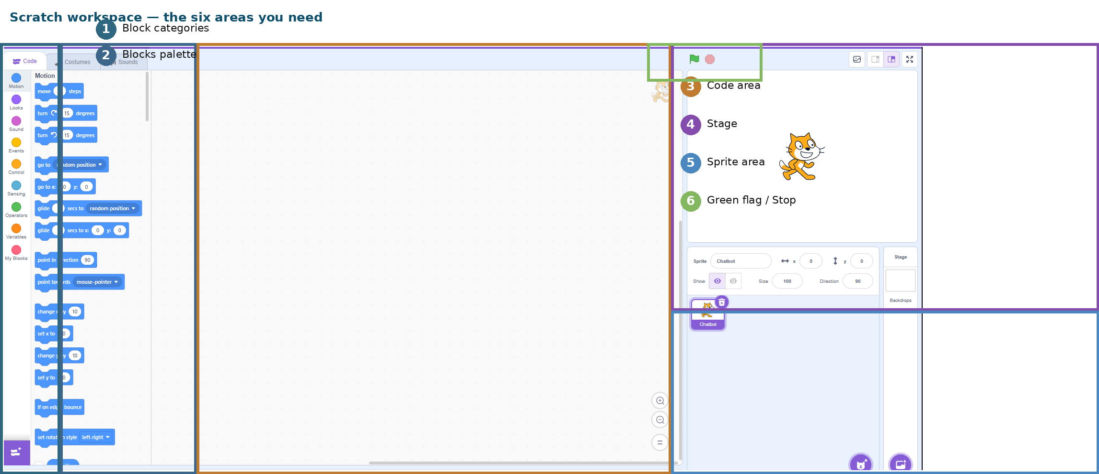
Figure 1. Scratch workspace orientation: categories, blocks palette, code area, Stage, sprite area and green flag / Stop.
Area | What students do there
1 Block categories | Choose the type of block.
2 Blocks palette | Find and drag the selected block.
3 Code area | Connect blocks into the chatbot script.
4 Stage | Watch what the sprite says and check the user experience.
5 Sprite area | Select and rename the chatbot sprite.
6 Green flag / Stop | Start the prototype or stop the current run.

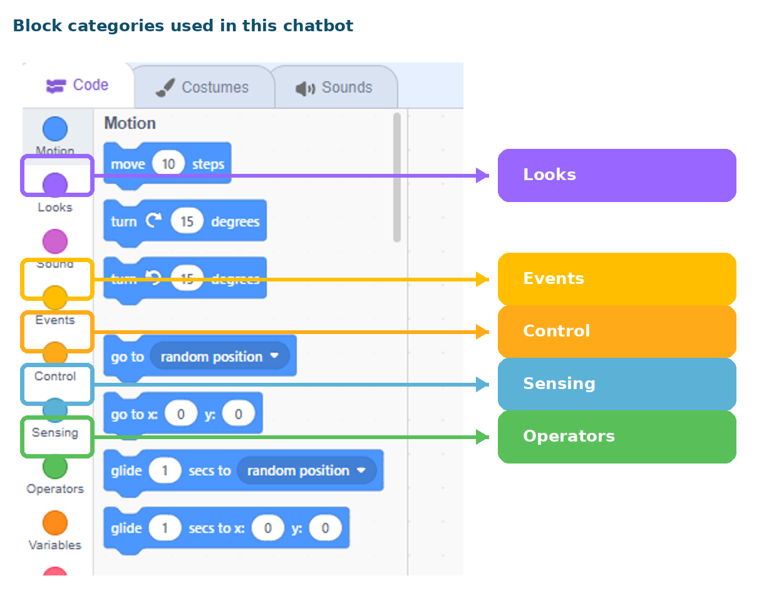
Figure 2. The five categories used in this task: Events, Looks, Sensing, Control and Operators.
Category | Blocks used | Purpose
Events — yellow | when green flag clicked | Starts the chatbot.
Looks — purple | say [ ] for [ ] seconds | Displays the introduction, approved responses, fallback and limits.
Sensing — light blue | ask [ ] and wait; answer | Collects the user choice and reports what was entered.
Control — orange | if [ ] then / else | Routes the user to the correct response.
Operators — green | [answer] = [number] | Compares the user entry with 1, 2, 3 or 0. The = block is diamond-shaped.

Four beginner actions
DRAG a block from the palette → CONNECT it under the previous block → RUN with the green flag → SAVE before leaving. The shape guides the connection: stack blocks connect vertically, oval reporters fit inside inputs, and the green = operator is a diamond condition.

4. Screenshot-based build sequence
The screenshots are topic-neutral. Students replace bracketed placeholders with the approved Part 2 wording. The teacher may project each step and pause for a class checkpoint.

Step 1 — Start the chatbot and introduce its purpose
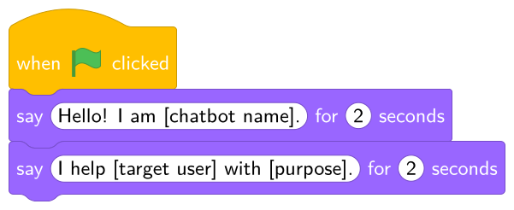
Figure 3. Add the green-flag start and the approved chatbot name, target user and purpose.
What to add | Why it matters | Checkpoint
when green flag clicked | Provides a predictable start. | Green flag begins the script.
two short say blocks | Makes the approved identity and purpose visible. | Text matches Part 2; no new scope is added.

Step 2 — Show the choices and collect one user entry
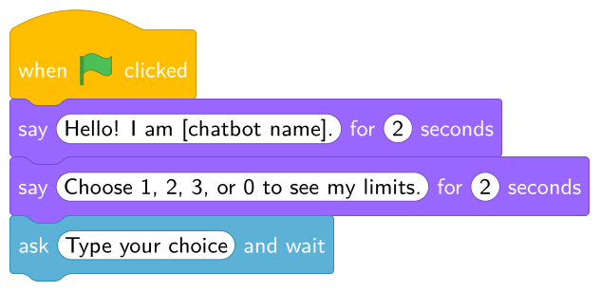
Figure 4. Display the 1–2–3–0 contract, then use ask and wait.
Use the approved category names in the menu sentence. Keep 0 as “see my limits” or an equivalent short label. The answer reporter stores the user entry automatically; students do not need a variable.

Step 3 — Connect choices 1, 2 and 3 to the approved responses
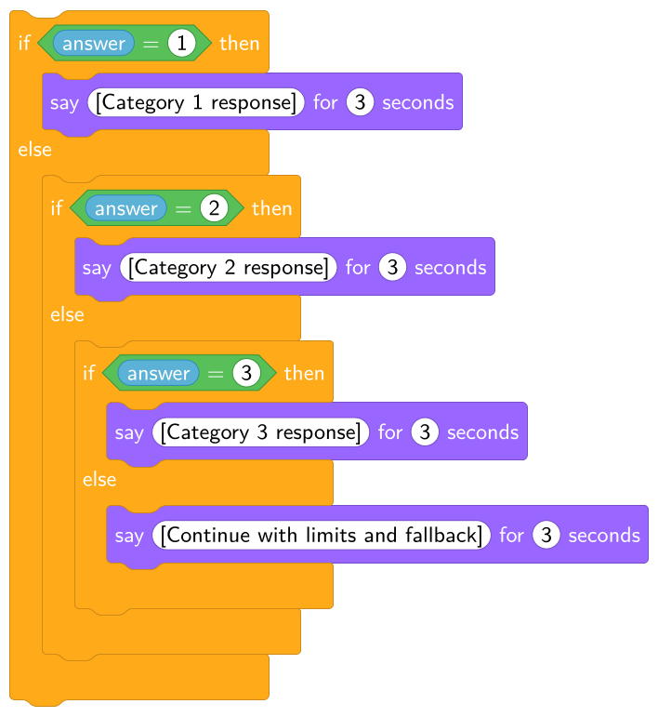
Figure 5. Build nested if/else branches for the three content categories.
Build action | Technical checkpoint
Place answer inside the left side of the green = operator. | The blue oval answer reporter is inside the green diamond.
Type 1, 2 and 3 on the right side of the three conditions. | Each number appears once in the correct branch.
Paste or type the approved response in the purple say block. | Response wording matches the Part 2 worksheet.
Build one branch at a time and run it. | Technical checking during construction is allowed; quality judgement is not.

Step 4 — Add a separate limitation route and the final fallback
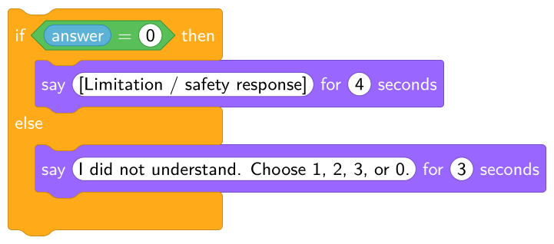
Figure 6. Choice 0 displays the approved limitation/safety response; the final else is fallback.
Trigger | Behaviour
answer = 0 | Say the exact approved limitation/safety response. It states the chatbot’s scope and points to a trusted human or reliable source where appropriate.
any other input | Say the approved fallback response and repeat how the user can continue, for example: “Choose 1, 2, 3, or 0.”

Do not merge them
Fallback means “I did not understand or recognise that input.” Limitation means “This request is outside my job or needs a person/reliable source.” They require different triggers and different messages.

Step 5 — Make the Part 1 principle visible
Use the planned visible feature from the Part 2 worksheet. Examples: a recovery-focused fallback, an honest limitation, a respectful response, a clearer start instruction or a category response that includes the information students found missing in Part 1. Do not invent a different feature during coding.
Part 1 principle example | Implementation location | Future Part 4 observation
A good chatbot should help the user recover when it does not understand. | Final fallback say block repeats 1, 2, 3 and 0. | An unclear input should lead to usable next steps.
A good chatbot should be honest about its limits. | answer = 0 branch. | The limits route should state what the chatbot cannot do and where to seek help.
A good chatbot should give clear, relevant information. | One approved category response. | A supported input should reach the intended specific response.

Step 6 — Compare the complete script with the blueprint
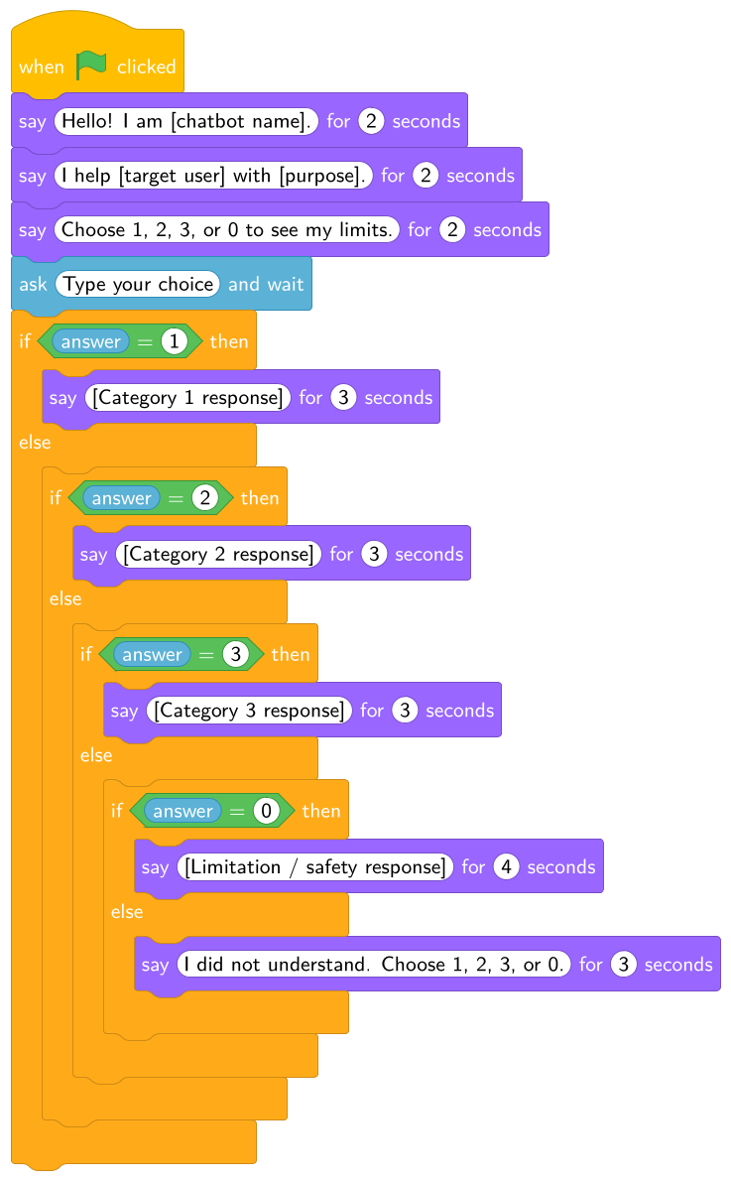
Figure 7. Topic-neutral complete Part 3 Scratch structure.
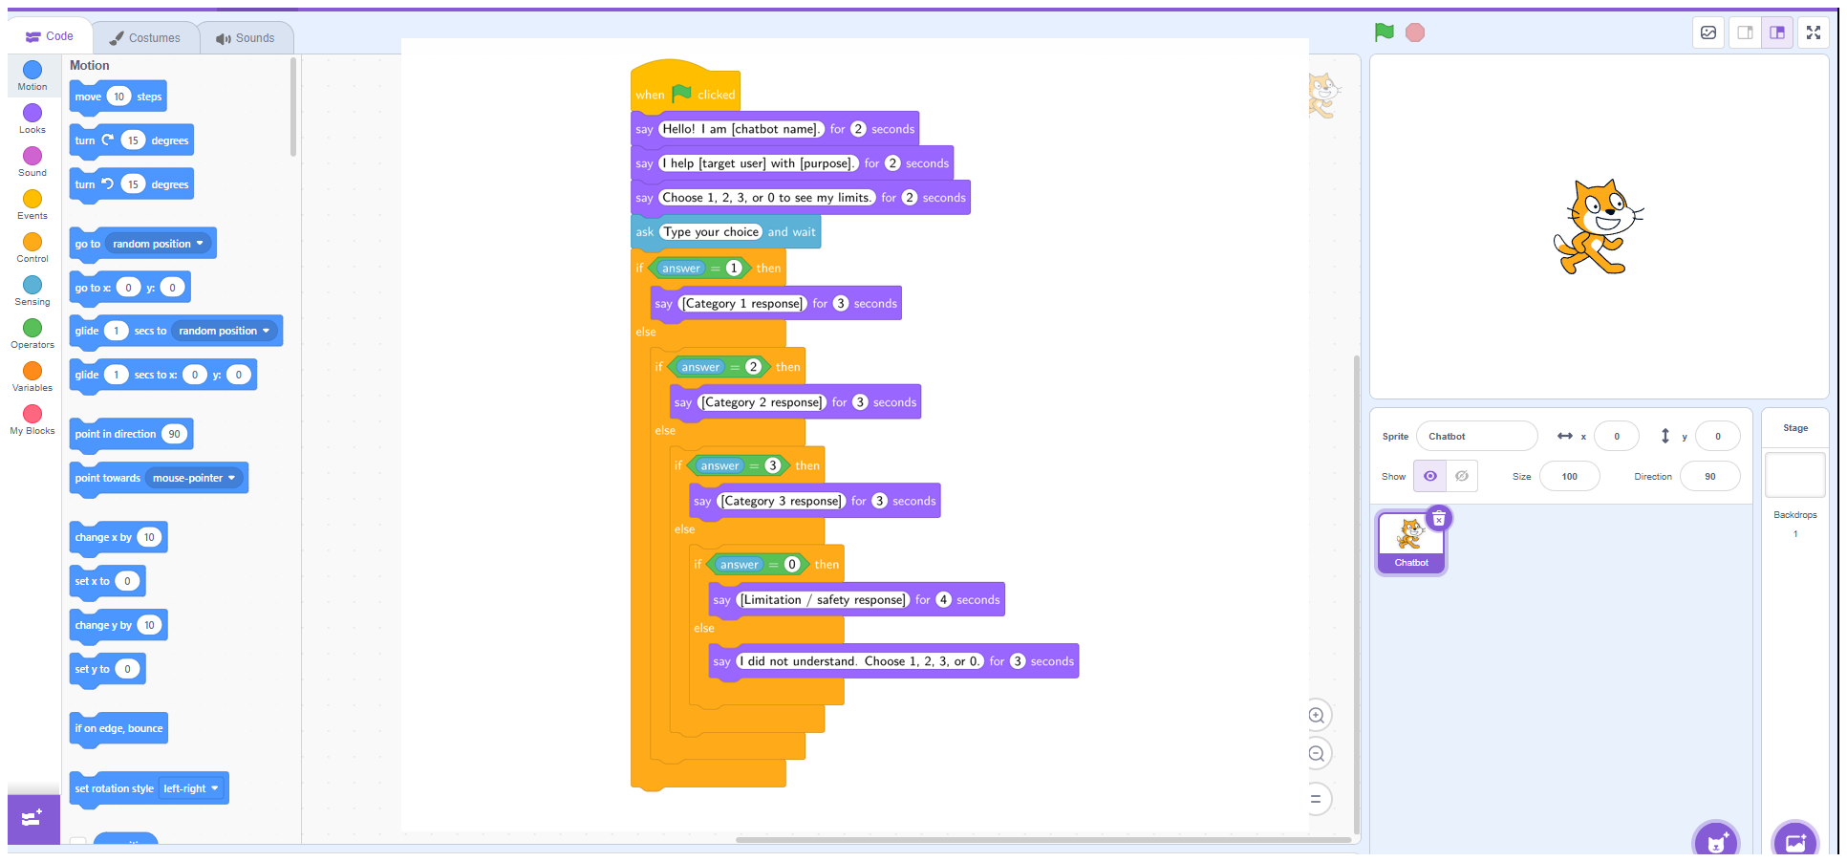
Figure 8. The complete structure placed in the Scratch code area.
The full script may look long because the if/else blocks are nested. Students should check it from top to bottom rather than moving blocks randomly. The content may differ by group; the minimum structure remains locked.

5. Worked completed example — Recycling Helper
The example is a model of structure, not a mandatory topic. It shows three content routes, a separate limits route and a recovery fallback.
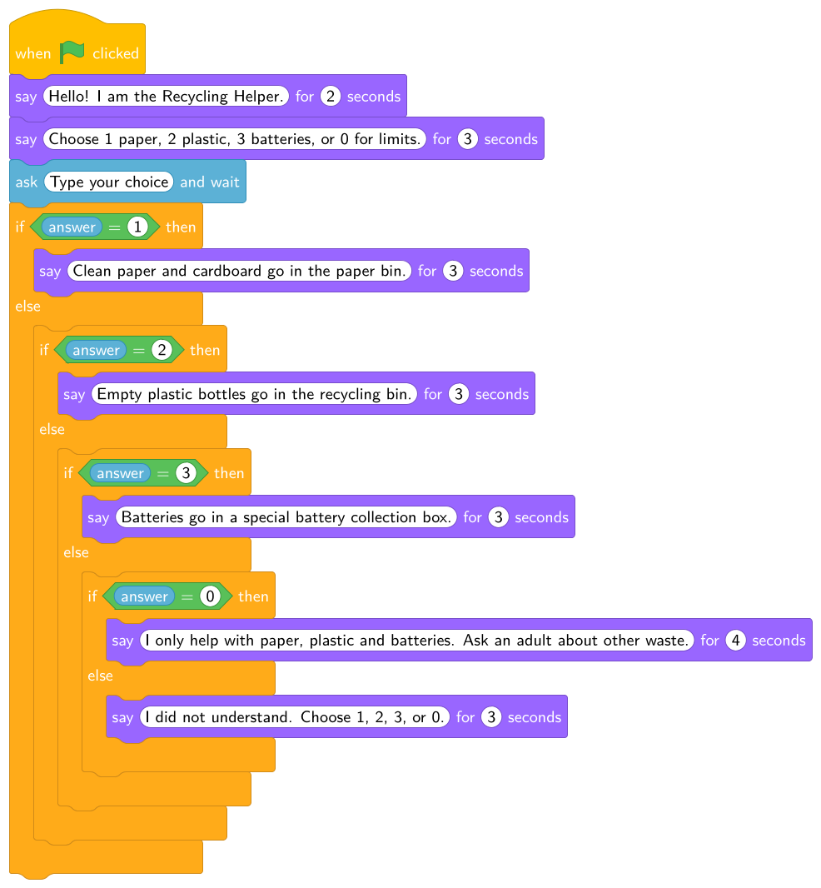
Figure 9. Completed example using fictional, school-appropriate content.
Part 2 element | Completed example
Purpose | Help a school user sort common waste.
Category 1 | Paper and cardboard.
Category 2 | Plastic bottles.
Category 3 | Batteries.
Limitation | Only these three materials are supported; ask an adult about other waste.
Fallback | Input is not recognised; repeat 1, 2, 3 or 0.
Possible Part 1 feature | Helpful recovery through an explicit fallback.

6. Build verification — not proper testing
Use page 3 of the common Prototype Build Record. Run each route once only to confirm technical reachability.
Check | What “Runs” means
Start/reset | Green flag begins from the introduction; Stop ends the run.
Instruction | User can see the available choices.
1, 2, 3 | Each number reaches the matching approved response.
0 | The limitation/safety response appears.
Other input | The fallback appears.
Part 1 feature | The planned block/message is present and reachable.
Save/access | The group can locate the project after saving.

Do not record quality here
Do not ask “Was the answer useful?”, “Did the fallback work well?”, or “Should we improve this?” Those questions belong to independent testing and review in Part 4 and the decision in Part 5.

7. Saving and handing over the Scratch project
• Use an anonymous title such as P3_Group04_LibraryHelper.
• When signed in, use Save now and confirm the project appears in My Stuff or the teacher’s studio.
• Without sign-in, use File → Save to your computer and store the .sb3 in the teacher-approved folder.
• Open the saved project once before ending the session.
• Record the link or filename on page 4 of the Build Record.
• Do not publish publicly until the teacher checks usernames, comments, project text and privacy.

8. Common implementation problems
Problem | Likely cause | Teacher response
Green flag does nothing | The event block is not connected to the script. | Move the complete stack directly under when green flag clicked.
Every input gives fallback | The answer reporter is missing, outside the = block, or the expected choice is typed differently. | Check the blue answer oval inside each green diamond and use plain 1, 2, 3 and 0.
A response appears under the wrong choice | Nested branches were connected in the wrong order. | Read the conditions top to bottom and compare each say block with the blueprint.
0 gives fallback | The answer = 0 branch is missing or placed after the final fallback. | Insert the 0 if/else before the last fallback.
Fallback and limits are identical | The two Part 2 messages were merged. | Restore the exact limitation in the 0 branch and fallback in the final else.
Script runs only once or seems stuck | A previous ask is waiting or the Stop button was not used. | Click Stop, then green flag. Do not add a forever loop for this minimum prototype.
Text is cut off too quickly | The say duration is too short for a long response. | Increase seconds as a technical display repair without rewriting the response.
Project cannot be found | Save method was not agreed or filename is unclear. | Use the standard group code, save again and reopen immediately.
Students start decorating | Core logic is incomplete. | Return to Part 3 Prototype Build Record implementation map; decoration is reserve work after save and verification.

9. Final Scratch readiness checklist
Check 1–5 | Check 6–10
☐ Part 2 blueprint remained the source of content.  ☐ Green flag start, purpose and user instruction are visible.  ☐ Choices 1, 2 and 3 reach the approved responses.  ☐ Choice 0 reaches limitation/safety.  ☐ Another unsupported input reaches fallback. | ☐ The Part 1 visible feature is present.  ☐ The project starts, stops, resets and saves.  ☐ The anonymous link/filename is recorded.  ☐ Page 4 Test Brief is complete.  ☐ Proper testing, Improve/Keep and final reflection have not been completed early.  ☐ Recycling Helper wording is not left in the submitted prototype unless recycling is the group’s approved topic.

